**A MAJOR PROJECT SYNOPSIS**

**ON**

Hotel Management System

**BACHELOR OF COMPUTER APPLICATIONS**

Degree

Session 2020-21







**SUBMITTED TO** **SUBMITTED BY**

MRS. MONIKA VARSHNEY ABHINAV RAY S/O NAVEEN KUMAR

AND

ARPIT PATHAK S/O NEERAJ PATHAK

AND

KARTIKEY MATHURIYA S/O SHYAM BABU MATHURIYA

|  |
| --- |
|  |

**TABLE OF CONTENTS**

PROJECT nAME

Project Synopsis

Vision Statement

Opportunity Statement

Scope

Goal

Features/Functionality

Use Cases Summary

Software and Hardware Requirement

Development Tools and Technologies

Front End

Back End

Development Environment

Visual Design

Data Dictionary

<Tables >

Data Schema ER Diagram

Data Flow Diagram

**Introduction of Project**

Hotel Management System is a software system where the management of entire hotel is computerized. The hotel management system is designed using JAVA Swing as the rich GUI for front end and MySQL Server as the secured backend database.

In this project the details are maintained like customer details, employee details, booking details and billing details. Booking the rooms, vacating the rooms, the restaurant management, billing process, staff management etc all is computerized and the management is done without any difficulty.

The reports can be viewed completely and the head of the management daily or weekly or monthly can review it. For company auditing it will be more useful. This Proposed System will be interactive, faster and user-friendly for the end users. Using the hotel management system, the following activities can be performed.

* + Room Service
  + Check In
  + Check Out
  + Staff Master
  + Restaurant
  + Login

**Vision Statement**

The project “Hotel Management System” is aimed to develop to maintain the day-to-day state of vacation of residents, List of employees, List of customer, Restaurant etc.

There are following main objectives of the hotel**:**

* Records of data, salary etc structure of the employees of Hotel.
* Keeping records of vacation of resident.
* Keeping user satisfaction as at most priority.
* Scheduling the allotment of user with room to make it convenient for user.
* Scheduling the services of manager, employee, workers and driver and properly so that facilities provided by Hotel are fully utilized in effective and efficient manner.
* Keeping records of user check-in details accurately arranged order so that the treatment of Customers becomes quick and satisfactory.
* Keeping details about the users, their needs.
* Keeping the best hotel facilities.
* Keeping detail about restaurant.
* Maintain administration detail.

**Opportunity Statement**

The mission is to facilitate easy management and administration of a hotel with capabilities to do Booking of the rooms, Cash billing, Room service, Restaurant service, Restaurant billing, Total billing, Employees arrangement etc. using the automated hotel management software. One can keep detailed records or info on an unlimited amount of customers. The system lets the user know which all rooms are available for occupancy at any point of time. This makes the booking considerably faster. And thus helps the hotel in better management and reduce a lot of paper work as well as manpower.

**Scope**

The scope of Hotel Management System is as follow:

* Front-desk operations (customer management, room allocation, employee management).
* Accommodation (Hotel room management, staff schedules, inventory).
* Staff record Management.
* Available room record.
* Booked room record.
* Check-in and check-out.
* Customer record management.
* Restaurant veg & non-veg food operation.
* Staff scheduling.
* Admin login.

**Goal**

In Order for the goals of the automated system to be achieved the design of the Hotel Management System takes the following into consideration:

* The system must make the hotel services fully known to the customer such as the room details and pricing.
* The system must be able to search databases or records to provide quick result based on users query.
* The system should ensure data consistency and no duplication of data no matter how small.
* The system must be accessed only by authorized persons.
* The design (Graphical) must be comprehendible and not clumsy to the admin, easy to use, and easy to understand.
* The system must have access levels based on user roles such as Manager-Administrator-Accountant-Other staff.
* The system must carry out only actions specified by the user (browse, modify, delete, add).

**Features/Functionality**

The features or functionality of Hotel Management System is as follows:

* Dashboard
* Check In/Check-out Module
* Available and Non-Available Room Module
* Customer Details
* Staff Details
* Staff Scheduling
* Restaurant Veg & Non-Veg Meal
* Admin Login

**Use Cases Summary**

**1. Check-in and Check-out module:**

First greet the customer and we take the details of the customer so that we can verify the identity of that customer. Then, we will talk about the room i.e. either you want room for smoking area or not and we will also talk for spend the days. Then we provide the identity card number to you. When you will arrive we will ask your name and the date at which you have registered. We will give you the registration form so we can check you in and show the identity card and then how will you pay the money either by credit card, debit card, cash, etc. then we will provide you the room key.

When there is a time to check out then first we will see the room condition and if it is perfect then you can go and get the receipt from the counter. If you have any complain about our hotel then you can say without hesitation we will do our best at next time.

**2. Restaurant:**

This is the major facility which we provide to our customers. We have a proper kitchen with adequate staff and we also maintain a menu according to the demands of the customers. We also take further steps for proper hygiene in the kitchen. We also provide telephone facility so that the customers will order the food form their room.

**3. Staff management:**

We have created a proper staff as per need in the hotel. And we are selective in hiring our staff. We give them work according to their skills and we communicate with them properly so that they work properly. We also monitor who and when has changed the order status. Our staff uses their time efficiently as modifications of new orders go directly to the right department and everybody knows what to do next. We are in touch with them for their help.

**4. Admin Login:**

This aims to create hotel booking online. Customer can check the available rooms and the customer data. The user register and log into system. The administrator knows the details of room.

Software is being designed in such a way as they provide all the information to the customers including hotel rooms, specifications, and services provided. By this, it is the advantage for the customer to remove the existing flaws in manual system booking hotel rooms.

**Software and Hardware Requirement**

**Software Requirements:**

1. Operating System : Windows 7 and upwards operating system

2. JDK : Java SE Development Kit 11

3. Database : MySQL 8.0.17

**Hardware Requirements:**

4. Processor : Dual core Intel

5. Clock Speed : 2 GHz

6. Storage : 750 MB free disk space

7. RAM : 1GB or more

8. Keyboard : 101 Keys

9. Mouse : Optical Mouse

**Development Tools and Technologies**

1. **Front End –**

* **Java Swing** - Java Swing is a lightweight Java graphical user interface (GUI) widget toolkit that includes a rich set of widgets. It is part of the Java Foundation Classes (JFC) and includes several packages for developing rich desktop applications in Java. Swing includes built-in controls such as trees, image buttons, tabbed panes, sliders, toolbars, color choosers, tables, and text areas to display HTTP or rich text format (RTF). Swing components are written entirely in Java and thus are platform-independent.

1. **Back End –**

* **MySQL** - MySQL is a database management system. It may be anything from a simple shopping list to a picture gallery or the vast amounts of information in a corporate network. To add, access, and process data stored in a computer database, you need a database management system such as MySQL Server.
* **Java** - Java is a high-level programming language developed by Sun Microsystems. It was originally designed for developing programs for set-top boxes and handheld devices, but later became a popular choice for creating web applications.

1. **Development Environment –**

* **NetBeans -** NetBeans IDE lets you quickly and easily develop Java desktop, mobile, and web applications, as well as HTML5 applications with HTML, JavaScript, and CSS. The IDE also provides a great set of tools for PHP and C/C++ developers.

1. **Visual Design –**

* **Adobe Photoshop -** Adobe Photoshop is the predominant photo editing and manipulation software on the market. Its uses range from the full-featured editing of large batches of photos to creating intricate digital paintings and drawings that mimic those done by hand.

**Data Dictionary**

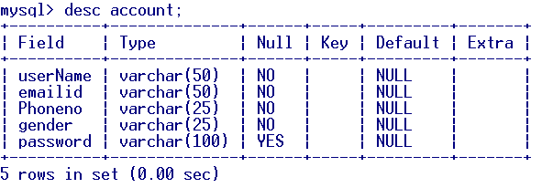

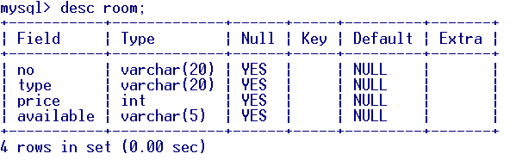

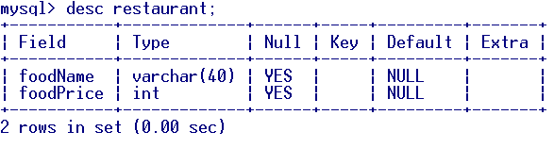

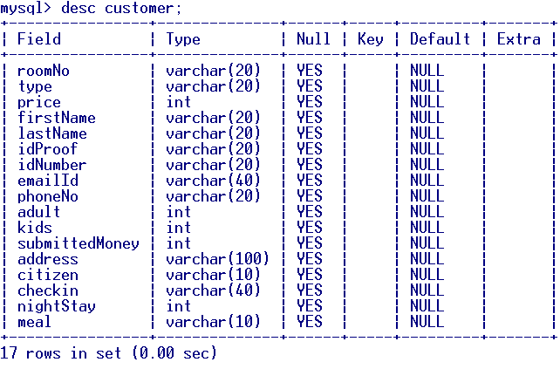

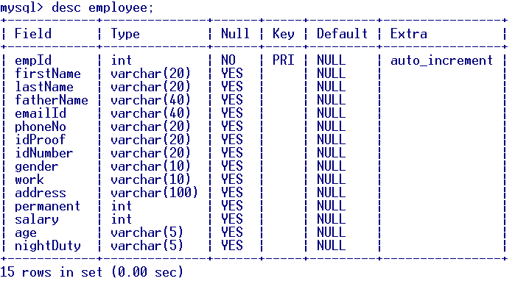

**Data Schema ER Diagram**

M

1

Food in

M

1

1

M

Order

Booked

Work In

1

N

Restaurant

Customer

1

Are in

Room

M

Account

Employee

**Data Flow Diagram**

Admin Detail

And Encrypt password

Admin

SQL: Account

Employee

Sign

In

Customer

SQL: Room

SQL: Room

Availability

SQL: Check Account

SQL: Customer

SQL: Restaurant

SQL: Employee